WELCOME PACK FOR PARTICIPANTS OF
Youth Exchange
COMMON FUTURE
01/10. SEPTEMBER 2017 RUDNIK, SERBIA
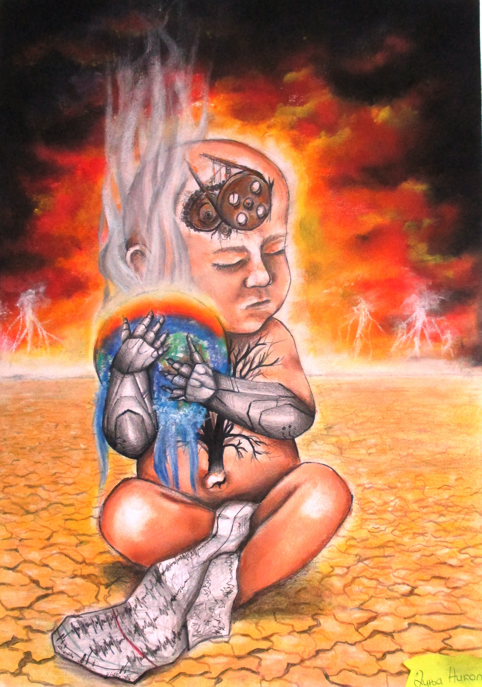

Project partners:

Volonterski centar Skopje (Macedonia)
Zveza drustev mladinski center Postojna (Slovenia)
Foundation for the Youth of Balatonalmádi (Hungary)
Environment Engineering Group (Serbia)

Dear Participants,

WELCOME ON YOUTH EXCHANGE (YE) COMMON FUTURE

Please find important information regarding your stay in Serbia and participation in the YE "Common Future"

In our YE will participate 28 participants from Macedonia, Slovenia, Hungary and Serbia. Every national group will have 6 youth people, from 18 till 25 years old, and 1 youth leader (there is no age limit for youth leaders).

In each national group 3 participants should come from group with fewer opportunities (Economic obstacles, Geographical obstacles or Educational difficulties). Other 3 participants should come from general youth population from 18 till 25 years.

This means every group consists of 1 youth leader + 6 participant (3 from general youth population + 3 from group of youth with fewer opportunities).

During 10 days of YE we will learn about the link between the climate change and migration phenomenon and how everyone’s lifestyle and everyday choices we make have an impact on itJ.

Youth Exchange will be organized in Hotel NEDA, www.togm.org.rs/sme%C5%A1taj/rudnik/hotel-neda.html,on the Rudnik mountain in central part of Serbia, near the city of Gornji Milanovac. More information about Gornji Milanovac you can find on www.togm.org.rs but only in Serbian language, and about Mt Rudnik on: https://en.wikipedia.org/wiki/Rudnik_(mountain)

TRAVEL

We expect you to come in Rudnik on 01.09.17. before dinner time.

There is a good bus connection between Belgrade and Rudnik/Gornji Milanovac.

More information about buses from Belgrade to Rudnik/Gornji Milanovac you can find on: http://www.bas.rs/basweb_eng/RedVoznje.aspx?lng=en

How to reach Rudnik

From the Airport “Nikola Tesla”
If you are coming in Serbia by plane you will come on Belgrade airport “Nikola Tesla” from where you have bus lines to the centre of Belgrade near to main bus station, from where you need to take bus to RUDNIK – Gornji Milanovac.
For more information how to reach main bus/train stations in Belgrade see http://www.beg.aero/en/strana/8811/bus.

From Belgrade train/bus station
If you come on main bus or train station Belgrade you will need to take bus for RUDNIK – Gornji Milanovac. On bus station on Rudnik someone from hosting team will wait you and gave you ride to Hotel Neda. Bus ticket will cost around 1000 dinars (9 Euro)

When you start your trip from Belgrade to Rudnik or Gornji Milanovac please send SMS to Damir Vladovic +381 65 264 33 99 who will be responsible to pick you up on the bus station and bring you to Hotel Neda.

If you need some additional help in organization your trip send us e-mail on izzsns@yahoo.com and we will help you.

Number of the participants per partner organization and travel costs:

Partner organization | Number of participant | MAXIMUM reimbursement for travel cost per participant, in EUR
Volonterski centar Skopje  (Macedonia) | 7 | 180
Zveza drustev mladinski center Postojna (Slovenia) | 7 | 180
Fundation for the Youth of Balatonalmádi (Hungary) | 7 | 180
Environment Engineering Group (Serbia) | 7 | 180

Reimbursement of travel cost

According to the rules of Erasmus+ Programme we will cover 100% of food and accommodation costs. Travel costs will be reimbursed up to the amount, shown in a table above, per participant. In a case that participants travel cost more than the amount allocated, unfortunately we will not be able to cover these additional costs.

Reimbursements will be done after the YE via bank transfers to the account of the partner organization following the reception of all invoices and original tickets.

ACCOMMODATION AND WORK

Rooms will be for 3 or 4 person. We will work in hotel but also we will have activities outside. Bring shoes and clothing for work outside in nature, walking in nature and sports activities. We expect nice weather but nights on Rudnik can be cold so please bring some jacket or sweater.

Every country group will have a task to present its country to the other participants during the YE. Time for presenting your counties will be during the Intercultural nights (02.09./03.09./04.09./07.09./08.09.). Also, all participating youth groups have to make a presentation about the immigration state in their respective countries.

For Intercultural nights we expect that you present to the other participants why people in your country are special and what are facts about your country that we need to know. Also, you can bring some traditional food and drinks to present to others. Each team will have up to 30 minutes to present its country to others. Use your imagination, knowledge and creativity and make it interesting and funny. National clothes, music, flags and other things are welcomed! ☺

ARRIVAL OF PARTICIPANTS
ALL PARTICIPANTS NEED TO BE AT HOTEL NEDA LETEST AT 1.9.2017. at 15:00 !!!
If you can not reach hotel Neda until 15:00 at 1.9.2917. please come day earlier (31.08.2017.) in hotel Neda. All cost of accomodation and food for aditional night will be cover by EEG.

DEPARTURE OF PARTICIPANTS
ALL PARTICIPANTS NEED TO PARTICIPATE IN LAST SESION ON 10.09.2017. util 13:00 !!!
Plan your departure from hotel Neda for 10.9.2017. after 13:00. If you can not organize your departure for 10.9.2017. after 13:00, plan to departure from Hotel Neda next day (11.09.2017.). All cost of accomodation and food for aditional night will be cover by EEG.

ALL PARTICIPANT NEED TO PARTICIPATE IN ALL ACTIVITIES PLAN IN PROGRAM :-)

DRAFT OF TIMETABLE- Activity Programme
Timetable | Activities | Non-formal & Informal learning methods used
DAY 1
AM | Arrival of participants | Participants are expected to arrive to Rudnik until lunch time.
PM | Introduction of participants and program. Knowing each other. Expectations from youth exchange. | The Youth Exchange will start by introducing participants and program. Name and ice breaking games will be used for the introduction of participants. Every group will prepare and introduce one name game and one ice breaking game. After the games, project leaders will present the program and lead workshop in which participants will be able to express their expectations, contributions, concerns and fears.
Evening | Welcome party | Youth from Serbia will organize some name and ice breaking games that will be followed by the party with international music.
DAY 2
AM | Creating group rules. Erasmus + presentation. Presentation of YouthPass and Key Learning competences | Participants will be asked to share their ideas for the establishment of working rules. These will be discussed and the participants will all together create and sign a group contract. Interactive presentation of Erasmus + Programme will follow. It will include a part about the Youth Pass, its understanding as well as of the key learning competencies. By the end of the youth exchange the participants will receive a Youth Pass as recognition of their learning process. Following, the principles of non-formal education will be presented by the youth leader.
PM | Team building | Every group will prepare and present two team-building games in front of the rest of the participants. This session aims to build strong teams and to create a safe and motivating environment for future work.
Before dinner | Reflection Time and Youth leaders meeting | Each day the participants in their national teams will have a time reserved for the discussion about the daily activities. This reflection will lead a group leader where the participants will provide a feedback about practicalities, interaction with others as well as about their learning process and development of their competencies. This information will be gathered by the youth leader and on the last day of Youth exchange it will serve to participants to fill up the Youth Pass form. Afterwards, this feedback will be discussed on the youth leaders’ meetings and according to it the program and logistic support will be adjusted if needed.
Evening | Hungarian night | Hungarian group will organise the activity for this evening, presenting its culture with the special focus on minorities and refugee issues of its country.
DAY 3
AM | History of migrations | Through the workshop led by the youth leader the development of human civilisation and the largest migrations taking part throughout the history will be presented to the participants. The focus of this presentation will be on migrations throughout the European continent. Using the methods of the timeline and the quiz participants will learn in an interesting way that the process of migration is a common phenomenon appearing all along the human history and that the nowadays states and the nations are the result of migration.
PM | Migrations in my country | Before the exchange, each group was in charge to prepare a short workshop presentation about the history of migration in their country examining the reasons why these migrations occurred. The young participants of each country will present their prepared workshops / presentations to the other participants.
Before dinner | Reflection Time and Youth leaders meeting | As mentioned in the program for the day 2 the participants will share their feedback within their national teams, further to what the youth leaders of each team will gather to discuss it.
Evening | Macedonian night | Macedonian group will organise the activity for this evening, presenting its culture with the special focus on minorities and refugee issues of its country.
DAY 4
AM | Climate changes and who cause them? | Igor Jezdimirovic as a youth leader will conduct this workshop. In an interactive and interesting way the climate change phenomenon, its causes and the ways how each of us contributes to it will be presented. During this activity, participants will have an opportunity to calculate their carbon footprint.
PM | What we can do to minimize our contribution to climate changes | This activity is a continuation of the morning workshop carbon footprint calculation. Based on the results they will be able to see which of their activities contributes the most to the climate change. According to the activities identified as the greatest transmitters of the greenhouse gases (GHG), young people will be divided into international groups where they will work on finding the solutions for the reduction of the GHG emissions. Furthermore, they will present their results to other participants.
Before dinner | Reflection Time and Youth leaders meeting | As mentioned in the program for the day 2 the participants will share their feedback within their national teams, further to what the youth leaders of each team will gather to discuss it.
Evening | Alternative night | Participants will organize their COMMON night.
DAY 5
AM | Migrations and climate changes | A senior youth leader and a member of the Management Committee of the Red Cross of Serbia, Milan Mirkovic, will lead the following workshop. During this workshop he will present the impact of climate change in the specific areas in the Middle East and in other parts of the world. Also, he will explain the consequences that arise due to climate change, emphasising those responsible for population migration. In addition, he will illustrate the current situation, future tendencies of of migrants in the so-called Balkan route. He will also underline the consequences that the building of walls can produce.
PM | How we can help migrants? | Following the morning activity, the young people gathered in the small groups will have time to discuss about the questions and facts previously learned. Afterwards they will have a task to propose concrete solutions to help to make life easier for migrants. This will help them to think about how young people can contribute to the whole society being involved in solving this problem while respecting European values, human rights and freedom of all.
Before dinner | Reflection Time and Youth leaders meeting | As mentioned in the program for the day 2 the participants will share their feedback within their national teams, further to what the youth leaders of each team will gather to discuss it.
Evening | Movie night | Each team will select a short movie (max. 15 min.) about the history of their country and the origin of its habitants.
DAY 6
AM | Visit to local cultural and historical monuments | As this part of Serbia is rich with the cultural and historical monuments, the excursions will be organised. Participants will visit Monastery Vraćevšnica, Museum in Gornji Milanovac, Hill of peace and a house of Norway-Serbian friendship.
PM | Meeting with youth from Red Cross Gornji Milanovac | Participants will meet with youth volunteers from Red Cross of Serbia. Red Cross volunteers will present them the activities of Red Cross with migrants and migrants’ problems and the participants will briefly explain the migration situation in their country and the influence that it has on the youth.
Before dinner | Reflection Time and Youth leaders meeting | As mentioned in the program for the day 2 the participants will share their feedback within their national teams, further to what the youth leaders of each team will gather to discuss it.
Evening | Free night
DAY 7
AM | Preparation of activity for local youth | In order to maximise the participation of the young people from the local community in the activities of the youth exchange, the participants will prepare a one-hour workshop for the young people from local schools as well as for those from the Red Cross. This activity should present to the young people from Gornji Milanovac the topic of the youth exchange as well as the opportunities offered by the Erasmus + program. Young people will independently determine which kind of activities to prepare as well as the content that will be presented. The material of Erasmus + program and the opportunities offered to young people in Serbia will also be prepared by a participant and distributed to local youth.
PM | Preparation of activity for local youth | Work on the preparation of activities for the local youth.
Before dinner | Reflection Time and Youth leaders meeting | As mentioned in the program for the day 2 the participants will share their feedback within their national teams, further to what the youth leaders of each team will gather to discuss it.
Evening | Slovenian night | Slovenian group will organise the activity for this evening, presenting its culture with the special focus on minorities and refugee issues of its country.
DAY 8
AM | Preparation of activity for local youth | Final preparation of the activities with the local youth
PM | Activity for local youth | For this activity, we expect the presence of 30 young people from Gornji Milanovac. The activity will be held in a space adequate for young people and the media representatives will accompany the event in order to disseminate the information about the project and its objectives to the largest number of the people, targeting the youth.
Before dinner | Reflection Time and Youth leaders meeting | As mentioned in the program for the day 2 the participants will share their feedback within their national teams, further to what the youth leaders of each team will gather to discuss it.
Evening | Serbian night | Serbian group will organise the activity for this evening, presenting its culture with the special focus on minorities and refugee issues of its country.
DAY 9
AM | Follow up activities | During this workshop, each group will develop a plan and timeframe for organizing events for youth in their local communities. This events will aim to transmit information and knowledge gained during the youth exchange, as well as to present the Erasmus + program. Each partner organization led by the youth leader will help the participants to organise this local event on the return from the exchange.
PM | Youthpass - Introduction of youth pass and time for reflection and documentation of competences get during Youth exchange | The purpose of the Youth Pass will be repeated to the participants and the way of its filling will be explained in detail. Furthermore, they will have enough time to complete and submit it to the youth leader of the EEG, who will print it and during the project evaluation deliver it to each participant.
Before dinner | Reflection Time and Youth leaders meeting | As mentioned in the program for the day 2 the participants will share their feedback within their national teams, further to what the youth leaders of each team will gather to discuss it.
Evening | Bye - Bye Party | Mixed team of participants will organize this party and activities during it.
DAY 10
AM | Evaluation of youth exchange and wrap up of youth exchange | During this session, overall youth exchange evaluation will be conducted. This evaluation will consist of the written survey, oral and visual evaluation activities. After the evaluation participants will receive the Youth Pass with what the youth exchange will be officially completed.
PM | Departure of participants | Departure of participants is expected after the lunch.

For your easy communication and preparation as country teams, here is the list of contact persons with e-mails.

For Macedonia Nikola Stankoski, nikola@vcs.org.mk
For Slovenia MajaMalec, maja@mcp.si
For Hungary EszterBeke, eszterbeke3@gmail.com
For Serbia Igor Jezdimirovic, izzsns@yahoo.com

If you have any questions regarding travel, accommodation, food, venue or anything else please contact:
Vladovic Damir by e-mail: vladovic.damir@yahoo.com and mobile phone (viber) +381 65 264 33 99.
Igor Jezdimirovic by e-mail: izzsns@yahoo.com and mobile phone (viber) +381 65 53 93 267.

Best regards and see you soon,

Environment Engineering Group TEAM

